St Paul’s Gift Day
October 2022

Dear St Paul’s family member,

Thank you for picking this document up. This contains a the details from our Treasurer Nelly’s Gift Day presentation and more. We hope it will help you pray for our church and its mission as well give you a better idea of what we are spending and why.

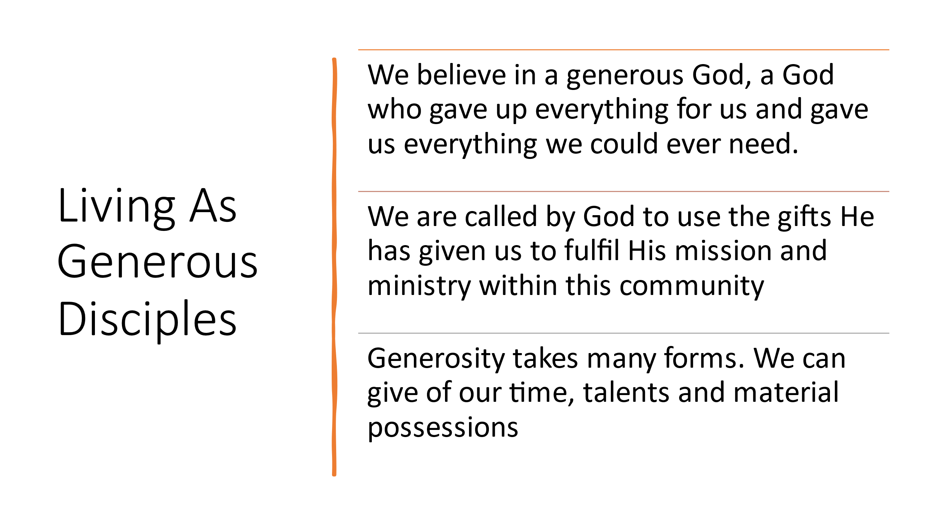

2 Corinthians 8 & 9 reminds us that our giving is about partnership in the gospel work here and overseas. It is also a wonderful and joyous privilege to express our gratitude and love for our Lord Jesus Christ. We praise Him for your ongoing giving to the church in all sorts of different ways, including financial. We are so grateful for ongoing giving month by month as part of you worship. Our Gift Day is a chance to prayerfully make a special, one-off donation to the church. This year we are asking for contributions to the General Fund. This gives the PCC the freedom to prayerfully direct our funding to the appropriate areas of need.

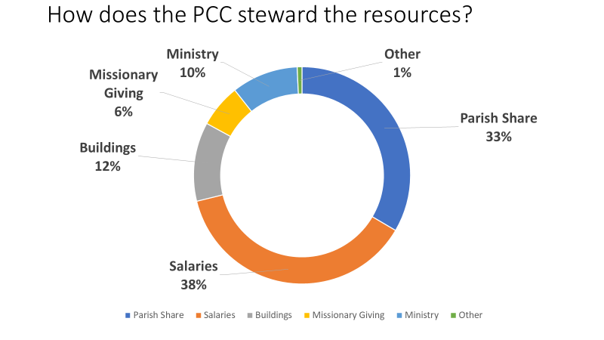
This year (2022) we have particular shortfalls coupled with a steep increase of attention needed to our church buildings. This has happened at a time our income is low. As you can see below we are facing a deficit of £31,000.
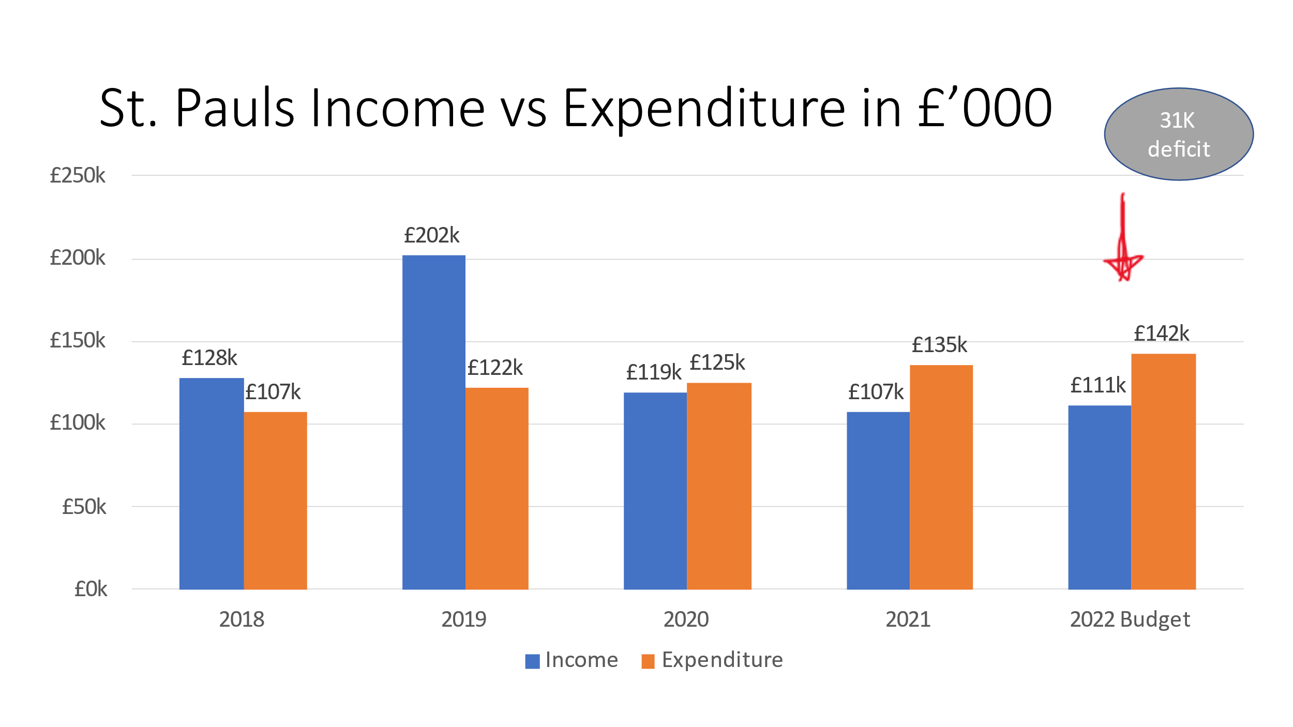

This means a gap has appeared in our funding. The columns below show the need:
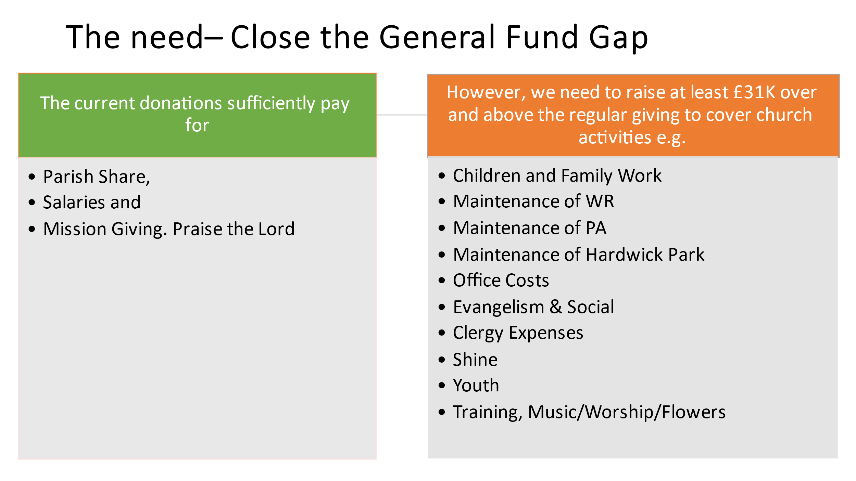
As mentioned, today we are asking for donations to the General Fund which gives us the flexibility to spend where the needs are. However, if you would like to give to one of the restricted funds (ring-fenced for specific needs) please let us know. This cannot be spent beyond the fund nominated. There is a list of Restricted Funds at the bottom of this document.

As well as serve the ministry with your giving we also encourage one another to PRAY. And wonderfully, we are allowed to pray BIG!

- Pray for the Treasurer & PCC as they steward the resources the Lord has given us
- Pray that we close the general fund gap
- Pray for the upcoming ‘root & branch’ financial review
- Pray for church families facing hardship in this difficult financial climate
- Pray that in all our financial dealings we will honour and glorify the Lord.
How to Give:

> Bank transfer is best, whether it be regular giving (Standing Order) or a one of gift.

Lloyds TSB Bank, Banbury,
Account Name: ST PAULS PCC BANBURY
Sort Code: 30-90-42
Account No: 00212790

> Cheques may be sent to the church office (payable to St Paul's PCC, Banbury)

> Cash – via a marked envelope placed in the basket at the back

> Standing Order Form below

GIFT AID
if you are a UK taxpayer, we can claim Gift Aid on your donation - complete a Gift Aid form below (also found on our website) or contact the church office for a paper copy.

Appendix
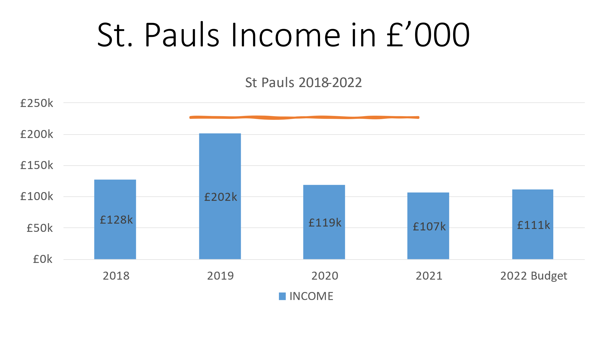

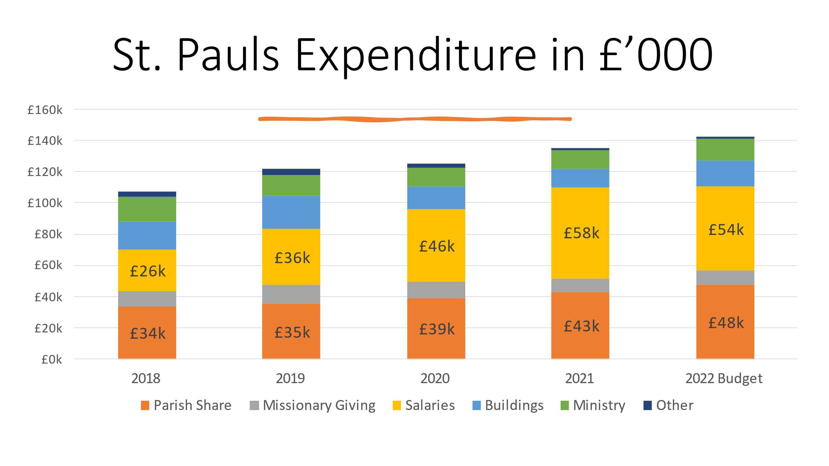

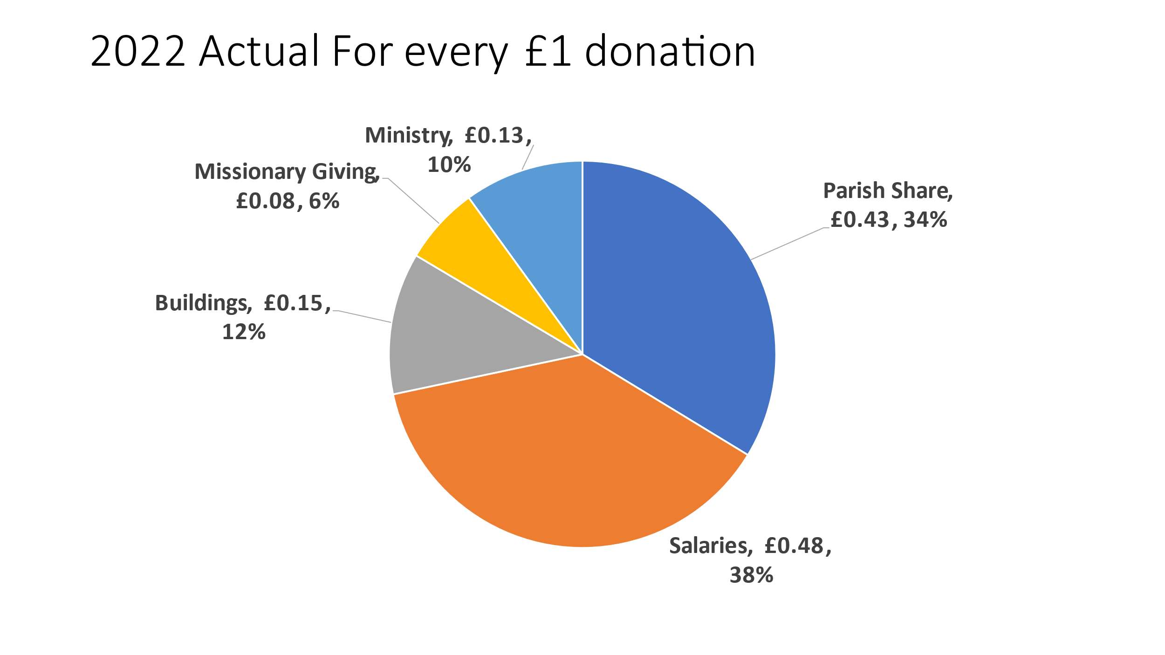
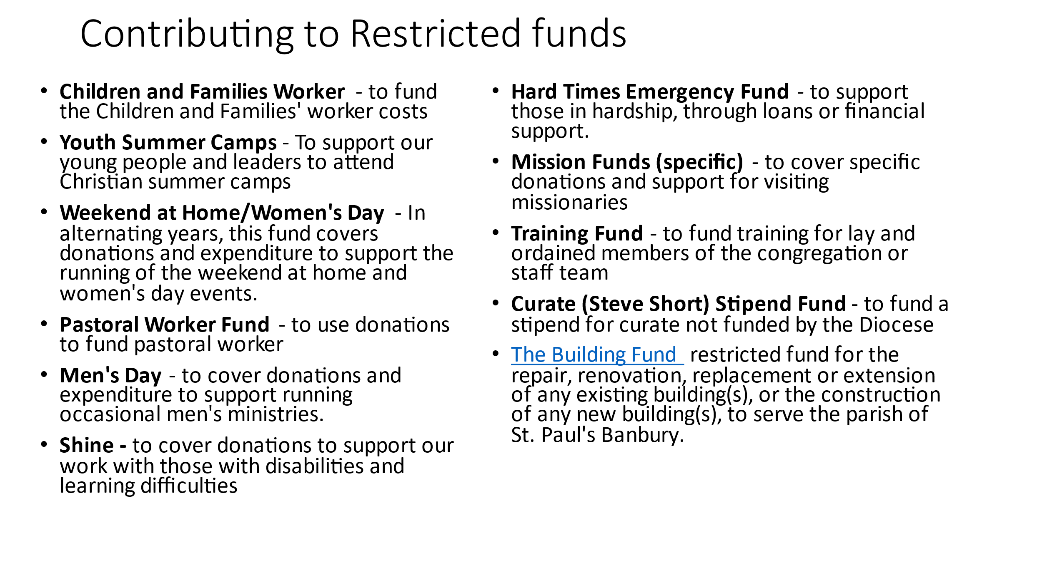

ST PAUL’S CHURCH, BANBURY

WARWICK ROAD & PRESCOTT AVENUE

STANDING ORDER FORM

To The Manager

…………………………………………………………. Bank (name of your bank)

…………………………………………………………. Branch

…………………………………………………………. Address

…………………………………………………………. Town & Postcode

Please pay by Standing Order to Lloyds TSB Bank, Banbury, Sort Code 30–90–42 for

the credit of St Paul’s PCC, Banbury, Account No 00212790

The Sum of £ …………………… (in words) .…………………………………………………………………

Commencing on ………………………….. (date – or immediately if left blank) and every month thereafter

Quoting reference ……………………………………………… (your name/names)

And debit my/our account No ………………….………. (your account number) accordingly

Signed …………………………………………………………… Date ………………………..

ST PAUL’S CHURCH, BANBURY

GIFT AID DECLARATION

Please treat as Gift Aid donations all qualifying gifts of money made from the date of this declaration and in the past four years.

I confirm I have paid or will pay an amount of Income Tax and/or Capital Gains Tax for each tax year (6 April to 5 April) that is at least equal to the amount of tax that all the charities (including churches and Community Clubs) that I donate to will reclaim on my gifts for that tax year.

I understand that other taxes such as VAT and Council Tax do not qualify, and that the church will reclaim 25p of tax (at the current rate) on every £1 I give.

Title …………… Surname ……………………………………

Christian Names ……………………………………………………………………..

Address …………………………………………………………………………………..

Post Code ,,,,,,,,,,,,,,,,,,,,,,,,,,,,,,,,,,,

Signature ……………………………….……………Date…………………………………………………..

NOTES

1. Please notify the church/charity if you:
• Want to cancel this declaration
• Change your name or home address
• No longer pay sufficient tax on your income and/or capital gains. Gift Aid is linked to basic rate tax. Basic rate tax is currently 20%, which currently allows charities to reclaim 25 pence on the pound.

2. Higher rate taxpayers can claim back the difference between basic rate and higher rate or additional rate tax. If you pay Income Tax at the higher or additional rate and want to receive the additional tax relief due to you, you must include all your Gift Aid donations on your Self Assessment tax return or ask HM Revenue and Customs to adjust your tax code accordingly

BANK ACCOUNT DETAILS:
Lloyds Bank Banbury
Account No. 00212790
Account Name: St Paul’s PCC Banbury
Sort Code: 30 – 90 - 42

